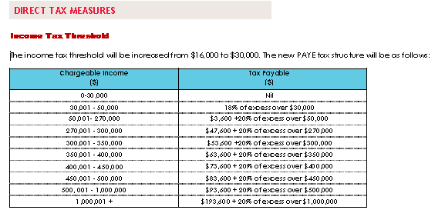

Given below is the SRT and ECAL table- revised one as per the meeting this morning. The resident and non-resident SRT and ECAL structure will be same as is the case now where there is no differentiation between resident and non-resident SRT rates.

Chargeable Income | Social Responsibility Tax Payable | ECAL
270,001 - 300,000 | 13% of excess over $270,000 | 10% of excess over $270,000
300,001 - 350,000 | 3,900 + 14% of excess over $300,000 | 10% of excess over $270,000
350,001 - 400,000 | 10,900 + 15% of excess over $350,000 | 10% of excess over $270,000
400,001 - 450,000 | 18,400 + 16% of excess over $400,000 | 10% of excess over $270,000
450,001 - 500,000 | 26,400 + 17% of excess over $450,000 | 10% of excess over $270,000
500,001 - 1,000,000 | 34,900 + 18% of excess over $500,000 | 10% of excess over $270,000
1,000,001 + | 124,900 + 19% of excess over $1,000,000 | 10% of excess over $270,000

