Figure 1: Tax Setup for Price Break.
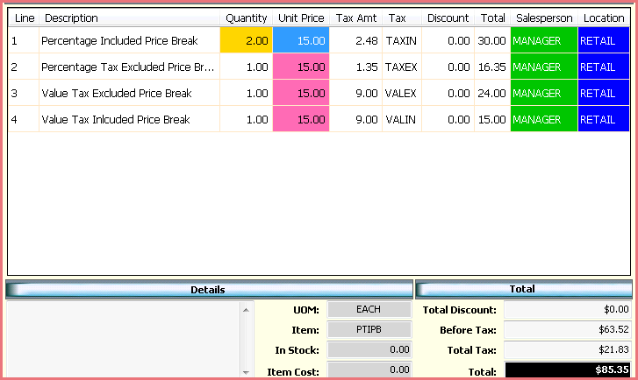

Figure 2: Tax Setup for Promotional Price
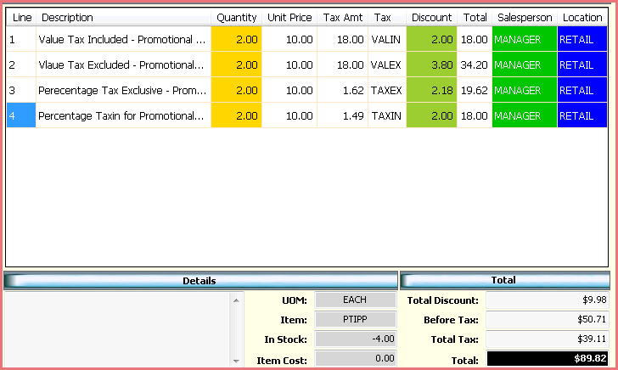

Figure 2: Tax Setup for Cost Plus Markup
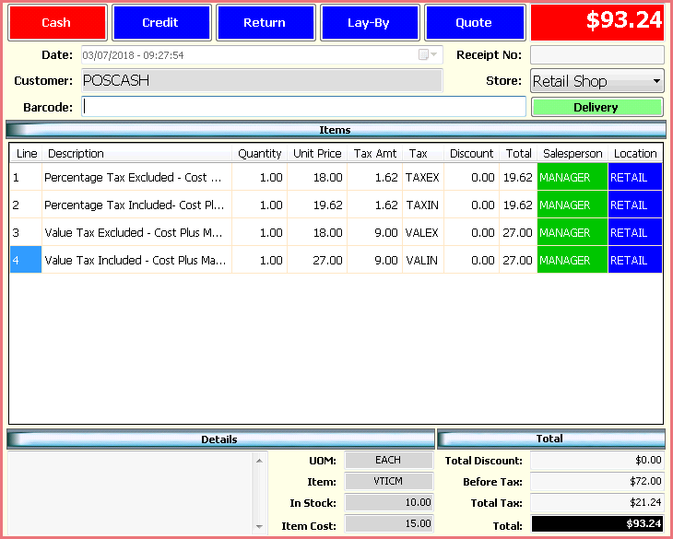
Figure 4: Tax Setup for Profit Margin
